AUTONOMOUS CAR RACING WITH DEEP REINFORCEMENT LEARNING
TEAM INFORMATION (GROUP -7):
Sonal Prasad - 017475432, Anoushka Sawant - 015154074, Sravani Neelapala - 016801486
DATA SOURCES: Gymnasium, Stable-Baselines
We are considering two environments– a built-in 2D and a 3D external environment:
The 2D car racing environment is part of the Box2D environments. It’s a top-down racing environment, with a random track in every episode. In continuous, there are three actions, and in discrete there are five actions. The observation has a top-down 96x96 RGB image of the car and race track.
https://gymnasium.farama.org/environments/box2d/car_racing
The 3D car racing environment uses Pybullet to simulate real-world physics. It includes observations such as pose, velocity, and rgb-camera, which are obtained by sensors. Similar to the 2D environment, it also has three actions in the continuous space. Vehicle and track configuration are customizable and multi-agent racing is possible with PettingZoo API.
https://github.com/axelbr/racecar_gym/
Baselines : Stable-Baselines (Pytorch) - SAC, PPO, DDQN
Google Drive Link: CMPE 260 Project
ABSTRACT:
Simple autonomous driving is a useful application of reinforcement learning. In our project, we will focus on autonomously navigating a race track. Potential actions include accelerating, breaking, and turning left and right. Rewards are granted based on proximity to the finish line. Our approach will involve benchmarking D-DQN (Double Deep Q Network) with PPO (Proximity Policy Optimization) and LSTM + SAC (Long Short Term Memory with Soft Actor Critic).
LITERATURE SURVEY:
We focus on model-free deep RL for driving: continuous-control methods like SAC and PPO, and discrete methods like DDQN. We also investigate how discretizing actions versus using continuous control affects stability and sample efficiency, and how robust agents should be to randomized tracks and seed variance in CarRacing-style benchmarks.
DATA EXPLORATION FOR 2D:
Box2D
We initialized and explored the “Box2D” environment from Gymnasium that simulates car racing based on physics. We experimented across continuous and discrete modes. We also adjusted the seed number for the environment which affects the randomization. The Google Collaboratory notebook below illustrates how the rewards change for 4 different combinations of modes and seed values. In both continuous and discrete environments, having a seed value of 42 led to higher returns (rewards) compared to the seed value of 0. We will be moving forward with the continuous mode.

The Google Drive folder contains videos of the car racing in 4 different modes. Additionally, it includes plots that are provided in the Google Colab.

Google Colab:
Exploring the Data.ipynb

Google Drive folder (CarRacing2D):
CarRacing2D

Box 3D (External environment)

We tried to get the 3D autonomous car racing simulation environment using the racecar_gym package, which is implemented on top of PyBullet and Gymnasium for simulating real car racing physics. We wanted to have an environment where we can then train reinforcement learning models for autonomous driving. We cloned the GitHub repository mentioned above in data sources for 3D and installed it by following the instructions, but we faced some technical issues in setting it up. The majority of the problems were because of version conflicts. Google Colab uses more recent versions of Python and NumPy that didn't align with the previous versions racecar_gym required and when tried locally faced similar challenges with dependency issues. Because of this, the environment could not be installed correctly, and we often ran into missing modules or dependency errors, especially for Gymnasium. We tried a number of solutions like reinstalling some versions, un-installing libraries with conflicts. While we weren't fully able to run the 3D environment by this time, we learned about how dependencies work together in complex environments.

Link for experimentation code: RacecarGym_3D_Setup.ipynb

Link for experimentation code: :3D_Experimentation.ipynb

RL ALGORITHMS
The algorithms we will be evaluating include DDQN, PPO, and SAC (with and without LSTM)

SAC with a CNN policy is up and running: a smoke test was performed at 20k steps. Next, we'll train SAC much longer (about 1-3 million steps) and save the best model along the way. For DDQN, we'll use a different set of discrete actions (a grid of steer and throttle options) with finer controls and evaluate on the same seeds. We trained SAC on CarRacing-v3 for only ~20k steps with 4 parallel environments and 4-frame stacking, then ran deterministic evaluations with a cap of 3000 steps. (The environment itself times out around 1000). Across five test seeds, every run hit the 1000-step time limit. This is normal for such a short training run and shows the pipeline works. We saved a short video-one episode-and a simple bar chart of rewards to our shared folder.

Link : https://colab.research.google.com/drive/1L6fDZZgxpz3yptoyTeYaajuWkbQZfIWN

Smoke test results:

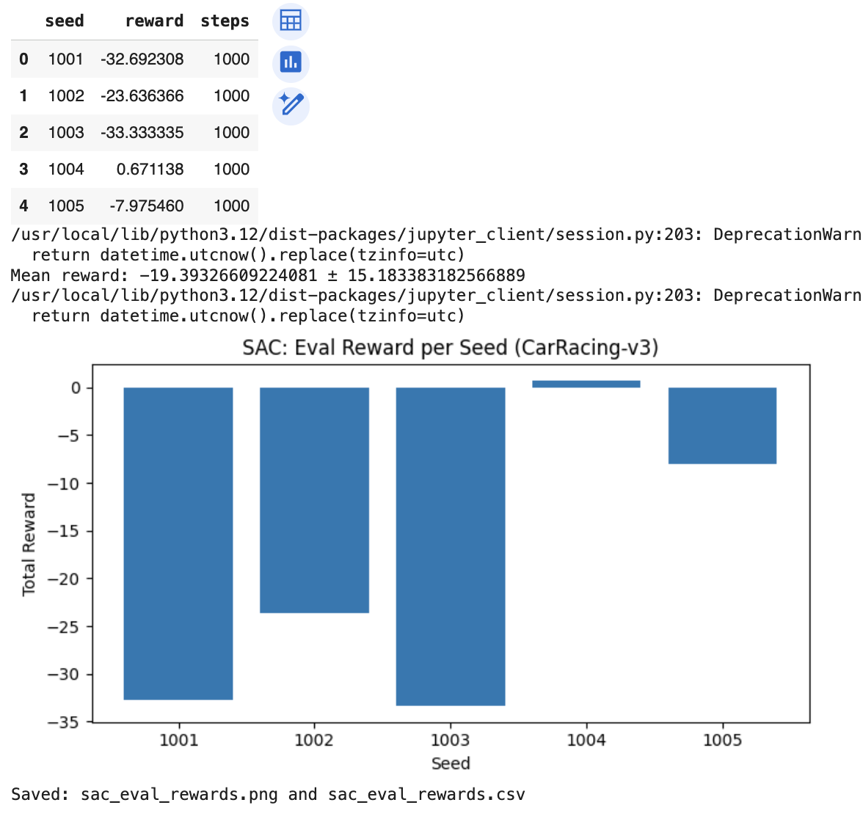

We will implement three RL algorithms for autonomous car racing: PPO, SAC and DDQN using Stable-baselines. All methods will be trained and tested on the Gymnasium CarRacing-v3 and we will report benchmark results, including learning curves between average returns and time steps, and short videos of representative runs.
REFERENCES:
https://github.com/axelbr/racecar_gym/
https://gymnasium.farama.org/environments/box2d/car_racing/
https://github.com/axelbr/racecar_gym/
https://github.com/DLR-RM/stable-baselines3/tree/master
https://github.com/openai/baselines
https://arxiv.org/pdf/2410.22766

